Rossmore Public School Canteen Menu “T3-T4 2011”

Hot Food Price Salad Boxes Price Snacks Price

Chicken Nuggets x 3 $2.00 Chicken and Salad $4.50 Popcorn Small $1.00
Twista Pasta Bolognese or Lasagne $4.00 Salad Only $4.00 Popcorn Large $2.00
Chicken Burger $4.20 Tuna and Salad $4.50 Smiths Chips $1.20
Pies $3.20 Custard $2.00
Sausage Roll $3.00 Paddle Pops, Splits,
Chicken and Corn Rolls $2.00 Sandwiches Price - variety of Ice Blocks $1.50
Hash Browns $1.20 1 Filling $2.50 Zooper Doopers 70c
Pizza Rounds $3.80 2 Fillings $3.00 Sunny Boys $1.20
Garlic Bread $1.50 3 Fillings $3.50 Ice Cream Cups $1.20
2min Noodles $2.20 (Fillings include ham, cheese, tomato, beetroot, Finger Buns $2.20
Hamburger $4.00 cucumber, lettuce, tuna or chicken) Fruca Stixs x 3 50c
Hot Dogs – Skinless Sausages $3.50 Jelly Cups $1.50
Sauces- BBQ or Tomato 25c Cup Cakes $1.20
Fruit Salad Small $3.50
Drinks Price Fruit Salad Large $4.50
Poppers (Orange, Orange & Mango, Apple & Seasonal Fruit Cups $1.50
Blackcurrent) $1.20 (Watermelon, Strawberries & Grapes)
Play or Focus Water $2.00
Ice Teas $2.20
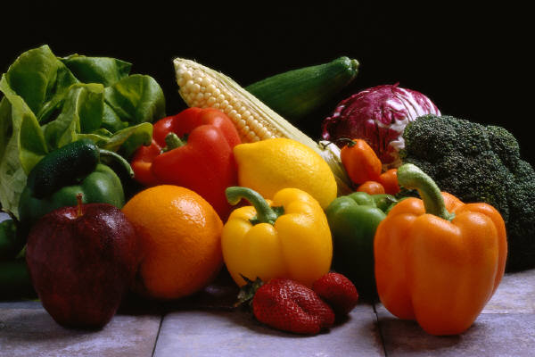
Blue Haven/Cola Quench $2.00
Fruit Sparkling Waters $2.00
Water $1.50
Juice Bottles – Apple $2.00
Sparkling Waters $2.00
Homemade Milkshakes (Choc/Straw) $2.70

